 | SLFUMC YOUTH 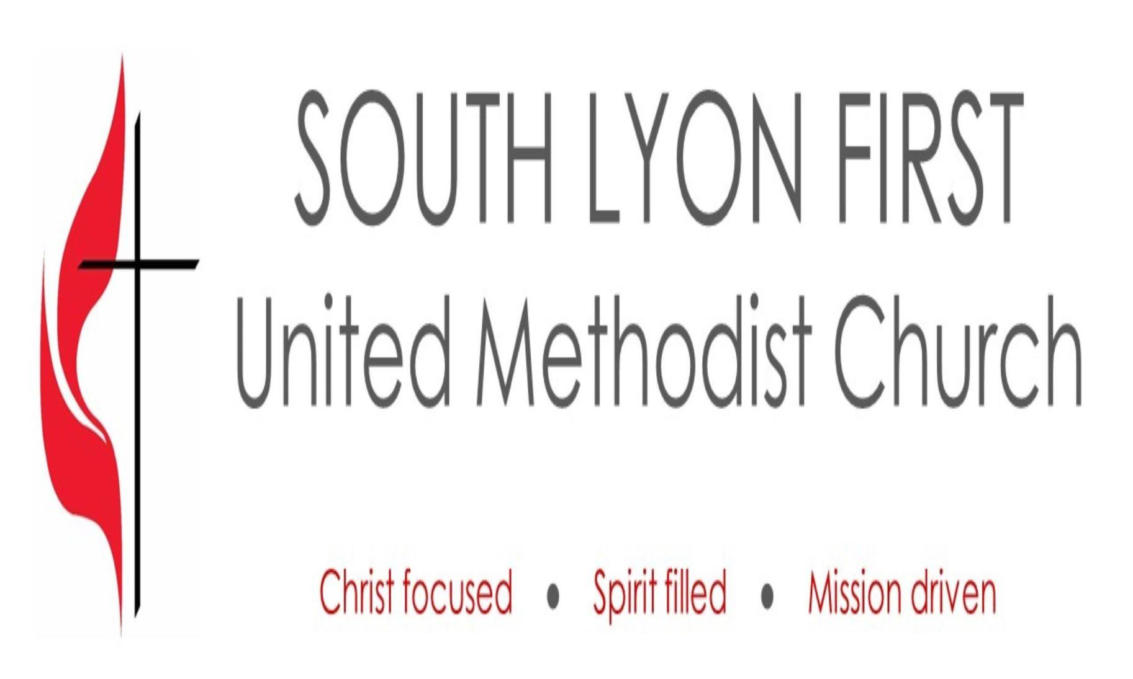
 | SEPTEMBER 2025
Tina: tinasain@southlyonfirstumc.org
What’s Happening with SLFUMC Youth  As most of you have probably heard or read by this point, I am stepping down as the Youth Coordinator and my last day will be September 30. My family and I will still be attending church, but I decided that for this time in my life, this role was not something I could continue.  I have had a lot of fun with the kids and have appreciated the opportunities to give back through our service projects. I hope to see everyone at The Church Has Left the Building on Sept. 14 and then again on Sept. 28 for our last fun event together before I am done.  I want to give an extra special thanks to the adults who stepped up to help on Sundays and at service opportunities, specifically Erin Petricca who went above and beyond the call of duty.  It is my prayers that all our youth and families have a great, safe school year! |  |  | What’s New?  The plan for this school year, pending changes by a new Youth Coordinator, is for there to be two gatherings a month. One will be a service project, and one will be an outing or a fun activity. |  | 
 |  |  |   Dates to Keep in Mind  Sept 14: The Church Has Left The Building  9:15AM  Sept 28: Fun activity (TBD) |  | “Whatever you do, work at it with all your heart, as working for the Lord, not for human masters, since you know that you will receive an inheritance from the Lord as a reward. It is the Lord Christ you are serving.”  -Colossians 3:23-24

